

18 December 2007

Sophia Lee
Program Coordinator, Curriculum & Assessment Office
Colleges of the Arts and Sciences

Sophia:

Attached is our revised request to have Engineering 360.01, History of Ancient Engineering, and 360.02, History of American Technology, approved as GEC Courses in the Historical Study category. As previously stated these courses have been approved by our college curriculum committee in December 2006 and Engineering representatives met with representatives from the Department of History in autumn 2006 concerning these courses. Their input was appreciated and their email response has been included with the enclosed material. All of their suggestions have been incorporated into the proposal. The changes implemented were:
- putting the courses into the history course group the Department of History suggested,
- including in the syllabi specific relationship between the readings and the weekly topics,
- including on the syllabi information on how the course objectives would be met, and
- changing the prerequisites for the courses from one history survey course to English 110 or equivalent.

The following changes have been made to the proposal based on input from your Subcommittee B:
  - The typographical corrections have been made.
  - Grading scales have been included.
  - The assessment plans have been removed from the syllabi and further developed.
  - The CVs have been removed.
  - Guidelines for the required report and presentation for 360.01 have been included.
  - A more detailed explanation of the required Patent Research Paper for 360.02 has been included.

The Course Learning Objectives of 360.01 can be mapped to the Goals/Objectives of the GEC Historical Study category in the following manner:

Course Learning Objectives of 360.01, History of Ancient Engineering | Goals/Objectives of the GEC Historical Study
1. acquire a perspective on history and knowledge of the genesis, evolution, and revolution of engineering;  2. understand the fundamental nature of engineering from various geographical, cultural, and historical perspectives;  3. achieve the historical awareness of functions, aesthetics, designs, and analyses of engineering works;  4. develop critical thinking about engineering problems as to how, why, and with what were engineering works constructed in the past;  5. comprehend historical engineering disasters and recognize that today’s and tomorrow’s successes are the fruits of yesterday’s failures;  6. place current engineering problems and issues in their larger historical context, and  7. increase their communications skills through essay exams, papers, and discussions. | 1. Students acquire a perspective on history and an understanding of the factors that shape human activity.
1. acquire a perspective on history and knowledge of the genesis, evolution, and revolution of engineering;  2. understand the fundamental nature of engineering from various geographical, cultural, and historical perspectives;  3. achieve the historical awareness of functions, aesthetics, designs, and analyses of engineering works;  4. develop critical thinking about engineering problems as to how, why, and with what were engineering works constructed in the past;  5. comprehend historical engineering disasters and recognize that today’s and tomorrow’s successes are the fruits of yesterday’s failures;  6. place current engineering problems and issues in their larger historical context, and | 2. Students display knowledge about the origins and nature of contemporary issues and develop a foundation for future comparative understanding.
4. develop critical thinking about engineering problems as to how, why, and with what were engineering works constructed in the past;  5. comprehend historical engineering disasters and recognize that today’s and tomorrow’s successes are the fruits of yesterday’s failures;  6. place current engineering problems and issues in their larger historical context, and  7. increase their communications skills through essay exams, papers, and discussions. | 3. Students think, speak, and write critically about primary and secondary historical sources by examining diverse interpretations of past events and ideas in their historical contexts.

The Course Learning Objectives of 360.02 can be mapped to the Goals/Objectives of the GEC Historical Study category in the following manner:

Course Learning Objectives of 360.02, History of American Technology | Goals/Objectives of the GEC Historical Study
1. To understand the evolution and history of technology in the United States.  2. To understand the impact technology has had upon the history of the United States.  3. To understand the interdependence of technological advances.  4. To understand how different cultures within the United States view technology.  5. To understand how technological failure can lead to technological advancement.  6. To be able to explain the United States Patent system and its contribution to technological advancement.  7. To increase their communications skills through essay exams, papers, and discussions. | 1. Students acquire a perspective on history and an understanding of the factors that shape human activity.
1. To understand the evolution and history of technology in the United States.  2. To understand the impact technology has had upon the history of the United States.  3. To understand the interdependence of technological advances.  4. To understand how different cultures within the United States view technology.  5. To understand how technological failure can lead to technological advancement.  6. To be able to explain the United States Patent system and its contribution to technological advancement. | 2. Students display knowledge about the origins and nature of contemporary issues and develop a foundation for future comparative understanding.
1. To understand the evolution and history of technology in the United States.  6. To be able to explain the United States Patent system and its contribution to technological advancement.  7. To increase their communications skills through essay exams, papers, and discussions. | 3. Students think, speak, and write critically about primary and secondary historical sources by examining diverse interpretations of past events and ideas in their historical contexts.

Further information on how each course meets these objectives can be found weekly topic breakdown for each course.

Students will sharpen their communication skills during their essay examinations, reports, and oral presentations. Students will be given rubrics which define the expectations and criteria for written and oral presentations. Feedback will be given through the grading process based on these rubrics. In addition, there will be structured discussions within the class environment.

Concerning the subcommittee’s other concerns:
- Our experience has been that the extensive disability statement answers many of our students’ questions.
- The three text books required for 360.02 can be bought on Amazon for less than $40.00.

If you or anyone on the GEC panel reviewing our request have any questions please feel free to contact me or Ed McCaul.

Sincerely
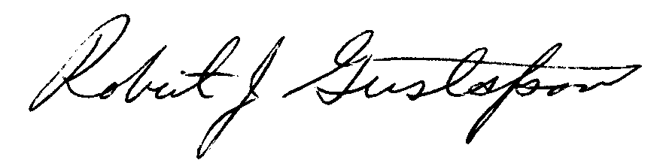
Robert J. Gustafson, P.E.
Associate Dean Undergraduate Studies and Student Services
Professor, Food, Agricultural and Biological Engineering

Inclosures:
Summary Sheet
Engineering 360 New Course Request (Generic Course)
Engineering 360.01 New Course Request and Syllabus
Engineering 360.02 New Course Request and Syllabus
E-mail message from Jennifer Siegel, Department of History
Assessment Plan for 360.01 & 360.02

